2016 MELGES24 MADNESS REGATTA

ACT 3 of the MELGES24 World Winter Series

March 17-20, 2016

Organizing Authority is the Miami Yacht Club

Miami, Florida

SAILING INSTRUCTIONS

- RULES
  - The regatta will be governed by the rules as defined in the Racing Rules of Sailing (RRS).
  - All competitors shall wear personal flotation devices while racing, except for brief periods while changing or adjusting clothing or personal equipment. Wet suits and dry suits are not personal flotation devices. This changes RRS 40.

1.4. Melges²⁴ class rules C.2.1, C.2.2, including initial weigh-in will be observed.

1.5. In all rules governing this regatta;

1.5.1 [DP] denotes a rule for which the penalty is at the discretion of the Jury; and

1.5.2. [NP] denotes that a breach of this rule will not be grounds for protest by a boat. This changes RRS 60.1(a).

- NOTICES TO COMPETITORS

Notices to competitors will be posted on the official notice board located at the MYC breezeway.

- CHANGES TO SAILING INSTRUCTIONS

Any change to the sailing instructions will be posted before 0830 on the day it will take effect, except that any change to the schedule of races will be posted by 2000 on the day before it will take effect.

- SIGNALS MADE ASHORE
  - Signals made ashore will be displayed from the flagpole at the MYC deck.
  - When flag AP is displayed ashore, “1 minute” is replaced with “not less than 60 minutes” in the race signal AP.

- SCHEDULE OF RACES
  - Schedule

Thursday, March 17

0900 - 1800 MYC Conference Room - Registration, weigh-in

0900 - 1500 Launching, MELGES²⁴ Speed Camp

1330 - 1530 Practice Racing

1630 - 1730 Video debrief

Friday, March 18

0800 - 0900 MYC Conference Room - Final registration, weigh-in

0900 All boats afloat & competitors meeting

1200 First warning for day one racing

1800 (est.) MYC Patio - Event Reception BBQ

Saturday, March 19

1000 First warning for day two racing

1630 (est) MYC Patio - Cocktail/keg and Video

Sunday, March 20

1000 First warning for day three racing

1500 Latest warning signal

After racing MYC Poolside Closing Ceremonies, all teams encouraged to attend
  - The RC will run as many races as practical, up to a maximum of 4 races per day.

- CLASS FLAG

The class flag will be a white flag with Melges²⁴ logo.

- RACING AREAS
  - The racing area will be outside the Government Cut on the Atlantic Ocean. See Attachment “A”.

- THE COURSES
  - The diagrams in attachment “B” show the courses, including the approximate angles between legs, the order in which marks are to be passed and the side on which each mark shall be left.
  - If only one leeward mark is present it shall be rounded to port.
  - The approximate magnetic bearing and distance in nautical miles to the first mark will be displayed from the race committee signal boat prior to the warning signal for each race.

Course example:
5 | Five legs, finishing to weather
270 | Approx magnetic bearing to the windward mark
1.2 | 1.2 nm to the windward mark

- MARKS
  - Marks 1, 2S and 2P will be Orange Tetrahedrons.
  - Mark 1a will be a small Orange ball.
  - The starting marks will be race committee vessels.
  - The finishing marks will be either two race committee vessels on a downwind finish, or a race committee vessel and an inflatable mark on an upwind finish.
  - New marks, as provided in Instruction 11.1, will be Yellow balls.
  - A race committee boat signalling a change of a leg of the course is a mark as provided in instruction 11.2.

- THE START
  - Races will be started using RRS 26 with the warning signal made 5 minutes before the starting signal.
  - The starting line will be between staffs displaying orange flags on the starting marks.
  - [NP] A boat starting later than 4 minutes after her starting signal will be scored Did Not Start without a hearing. This changes rule A4.
  - When an individual recall is signalled, the race committee will attempt to hail the sail numbers of the boats that are OCS over VHF channel 68. See also instruction 21.2.

- CHANGE OF THE NEXT LEG OF THE COURSE

11.1 To change the next leg of the course, the race committee will lay a new mark (or move the finishing line) and remove the original mark as soon as practicable. When in a subsequent change a new mark is replaced, it will be replaced by an original mark.

11.2 Except at a gate, boats shall pass between the race committee boat signalling the change of the next leg and the nearby mark leaving the mark to port and the race committee boat to starboard. This changes rule 28.

- THE FINISH
  - The finish line will be between staffs displaying orange flags on the finishing marks on a downwind finish, or between a staff displaying an orange flag on the finishing mark and a Green Tetrahedron on an upwind finish.

- PENALTY SYSTEM
  - Rule 44.1 is changed so that a boat may take a One-Turn Penalty when she may have broken a rule of Part 2 or rule 31 while racing. However, when she may have broken a rule of Part 2 while in the zone around a mark other than a starting mark, her penalty shall be a Two-Turns Penalty.”
  - Unless the course is shortened to finish at the windward mark, penalties while in the zone of the windward mark or on the offset leg may be delayed and taken as soon as possible on the downwind leg. This changes rule 44.2.

- TIME LIMITS
  - The time limit for the first boat to sail the course and finish is 90 minutes.
  - Boats failing to finish within 30 minutes after the first boat sails the course and finishes will be scored Did Not Finish without a hearing. This changes rules 35, A4 and A5.

- PROTESTS AND REQUESTS FOR REDRESS
  - Protest forms are available at the Upstairs Jury Room. Protests shall be delivered there within the appropriate time limit.
  - The time limit is 45 minutes after the race committee signal boat docks. The docking time will be posted on the Official Notice Board.
  - Notices will be posted within 30 minutes after the protest time limit to inform competitors of hearings in which they are parties or named as witnesses. Protest will be heard in their approximate order of receipt in the Upstairs Jury Room.
  - Protests regarding World Sailing classification must be submitted by the end of the protest time limit on the first day of racing. Such protests will be handled by the class office, whose decision is final. This changes rule 63.1.
  - Notices of protests by the race committee or protest committee will be posted to inform boats under rule 61.1(b).
  - On the last scheduled day of racing a request for reopening a hearing shall be delivered;
- Within the protest time limit if the requesting party was informed of the decision on the previous day;
- No later than 30 minutes after the requesting party was informed of the decision on that day.

This changes rule 66.

15.7 On the last scheduled day of racing a request for redress based on a protest committee decision shall be delivered no later than 30 minutes after the decision was posted. This changes rule 62.2.

- SCORING
  - Three (3) races are required to be completed to constitute a series.
  - When fewer than six (6) races have been completed, a boats series score will be the total of her race scores.
  - When six (6) or more races have been completed, a boats series score will be the total of her race scores excluding her worst discardable score.

- [DP][NP] SAFETY
  - Prior to the warning signal for the first race of each day in which it intends to compete, each boat is requested to check in by sailing by the race committee signal boat and hailing its sail number.
  - A boat retiring from a race or leaving the race area early shall promptly notify the race committee by hail or over VHF channel 68. Failure to do so may be grounds for protest.
  - Boats shall not impede the passage of commercial vessels and shall comply with the U.S. Inland Navigation Rules Act of 1980.

- [DP] REPLACEMENT OF CREW OR EQUIPMENT
  - The crew will consist of a minimum of three persons.
  - Substitution or deletion of competitors will not be allowed without prior written permission of the race committee.
  - Substitution of lost or damaged equipment will not be allowed unless authorized by the race committee. Requests for substitution shall be made to the committee at the first reasonable opportunity.

- [DP] TRASH DISPOSAL

As sailors, we seek to protect and restore our oceans and coastal waters. See rule 55. Trash must be contained on board and disposed of appropriately when back ashore.

- HAUL-OUT RESTRICTIONS

Boats shall not be hauled out during the regatta except with and according to the terms of prior written permission of the race committee.

- RADIO COMMUNICATION
  - Race committee broadcasts and hails will be made over VHF channel 68.
  - Race committee broadcasts regarding its intentions, the course to be sailed, starting times, course changes, recalls, etc., are a courtesy only. Failure of the race committee to make a broadcast, the timing of a broadcast, or the failure of a boat to hear a broadcast, shall not be considered grounds for redress.
  - Except in an emergency, a boat shall neither make radio transmissions while racing nor receive radio communications not available to all boats. This restriction also applies to mobile telephones.

- PRIZES
  - Prizes will be given to the top three teams overall.
  - Additional prizes may be awarded by the organizing authority.

- DISCLAIMER OF LIAIBILITY

Competitors participate in the regatta entirely at their own risk. See rule 4, Decision to Race. The organizing authority will not accept any liability for material damage or personal injury or death sustained in conjunction with or prior to, during, or after the regatta. Competitors accept full responsibility for their actions during any activity related to this event. This includes on-shore activities before, during, or after the regatta. Competitors are expected to conduct themselves in a sportsman-like manner at all times and to abide by the MYC rules.

- INSURANCE

Each participating boat shall be insured with valid third party liability insurance with a minimum cover of $500,000(USD) per incident or the equivalent. Competitors shall be prepared to provide proof of insurance upon request.

APPENDIX “A” - Approximate Ocean Racing Course Area

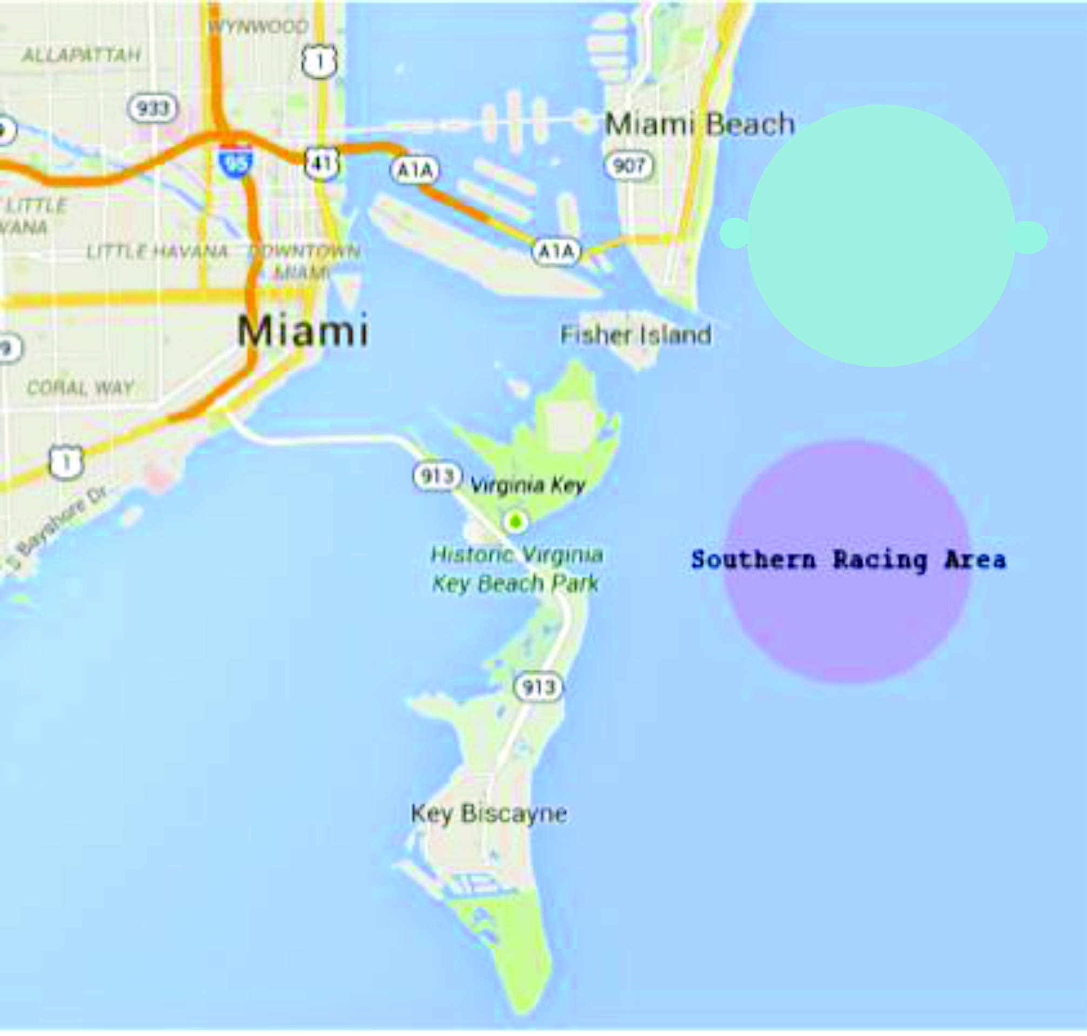

APPENDIX “B” - Course Layouts

COURSE 4 |  | COURSE 5

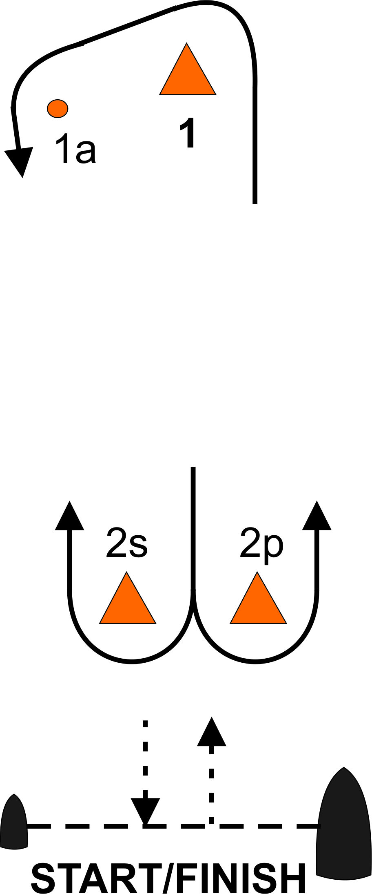
Start - 1 - 1a - 2s/2p - 1 - 1a - Finish |  | Start - 1 - 1a - 2s/2p - 1 - 1a - 2s/2p - Finish

